HTML PROJECT

Topic- University Management System(UMS)

Name- Satya Kumar Chaudhary

Roll no- RK22AEA31

Reg. No- 12203506

Course code- CSE326

### **Submitted To Dr. Richa Jain, Assistant Professor**

Lovely Professional University

Jalandhar, Punjab, India.

**University management system 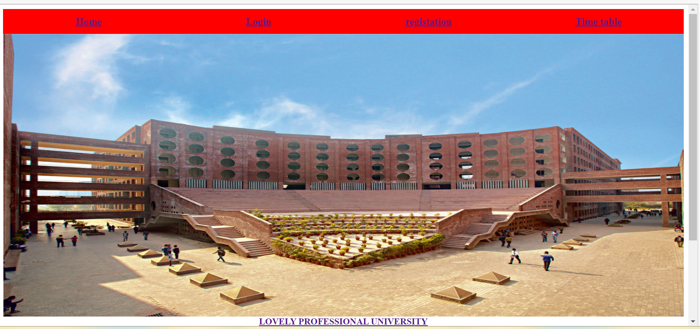 Code**

|  |
| --- |
| <html> |
| <head> |
| <style> |
|  |
| </style> |
| <meta name="viewport" content="with=device-width,initial-scale=1.0"> |
| <link rel="stylesheet" href="anchor.css 3"> |
| <title>Document</title> |
| </head> |
| <body> |
|  |
|  |
|  |
|  |
|  |
|  |
|  |
| <body background-color="red"> |
| <table border="0" width="100%" bgcolor="red" height="8%"> |
|  |
| <tr> |
|  |
|  |
| <th width="20%"><font color="white" size="4"><a href ="lpu.html">Home</a></font></th> |
| <th width="20%"><font color="white" size="4"><a href ="project html.html">Login</a></font></th> |
| <th width="20%"><font color="white" size="4"><a href ="registation.html">registation</a></font></th> |
| <th width="20%"><font color="white" size="4"><a href ="timetable2.html">Time table</a></font></th> |
|  |
| </tr> |
| </table><center> |
| <img src="C:\Users\Asus\Pictures\lpu..jpeg" width="1200" height="500"></center> |
| <center><a href="<https://lpuumslogin.sstalks.com/>"target="_blank"><b>LOVELY PROFESSIONAL UNIVERSITY</b></a></center> |
| <center><p>This is home page</p> |
| <h1>World's biggest university</h1> |
| <p>Making website is now one of the easiest things in the world .<br>you just need to learn HTML,CSS,JAVASCRIPT and you are good to do.</p> |
| <a href=""class="hero-btn">visit us to know more</a></center> |
| </body> |
| </html> |

**Home**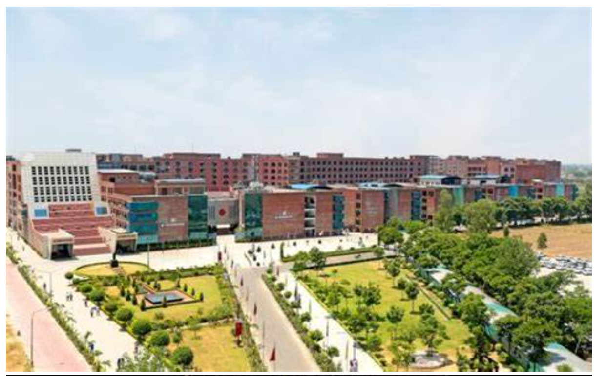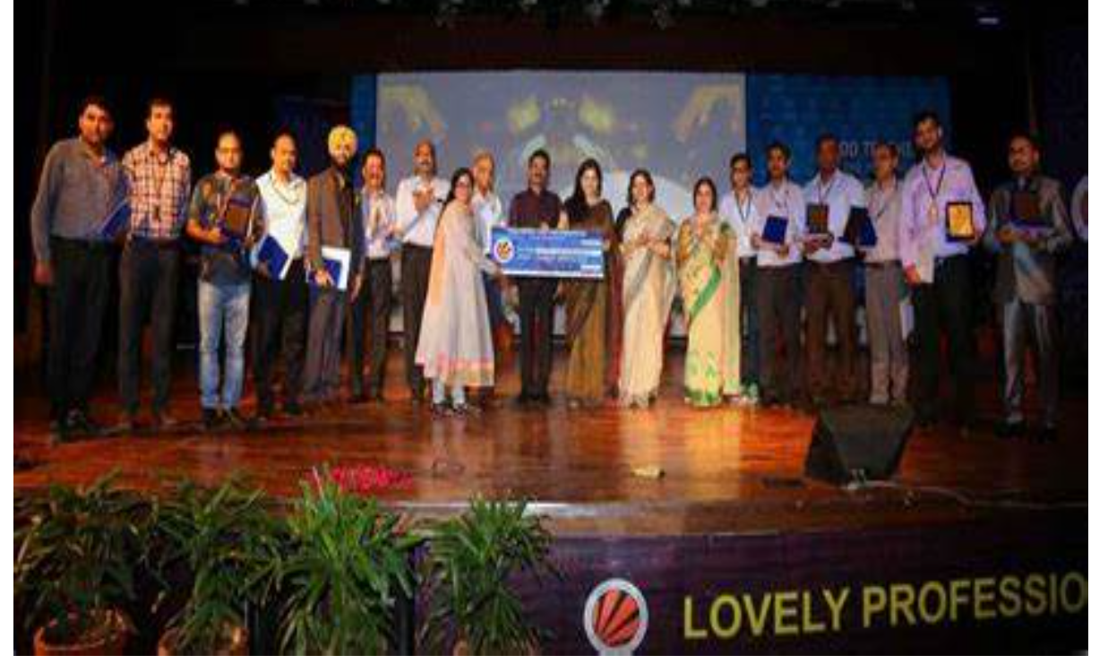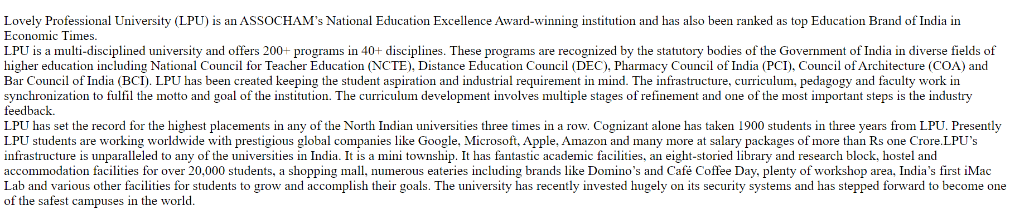

**Classroom**

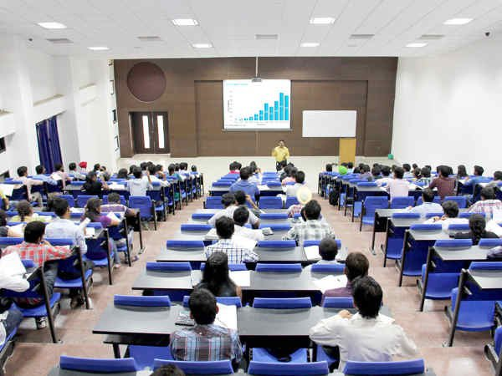

Lovely Professional University Classrooms are better then other universities classrooms. The class-rooms are standard, well fitted with students desks / benches with seats , podium , white board, projector, sound system ,CCTV camera, recording system and Air conditioning( used during the hot season)

**Code**

|  |  |
| --- | --- |
|  |  |
|  | <!DOCTYPE html> |
|  | <html lang="en"> |
|  | <head> |
|  |  |
|  | <title>Document</title> |
|  | </head> |
|  | <body> |
|  |  |
|  | <!-- saved from url=(0045)file:///C:/Users/Asus/Downloads/aboutlpu.html --> |
|  |  |
|  | <style> |
|  |  |
|  | </style> |
|  |  |
|  |  |
|  |  |
|  |  |
|  | <body background-color="gold" class="bk"> |
|  |  |
|  |  |
|  |  |
|  |  |
|  | <h1 class="green-text pstyle"> |
|  | <p align ="center"> |
|  | LOVELY PROFESSIONAL UNIVERSITY<br> |
|  | PANJAB<br> |
|  | INDIA<br> |
|  |  |
|  |  |
|  | </p> |
|  | </h1> |
|  | <div class="target"> |
|  | <div id="About"><center> |
|  | <img src="C:\Users\Asus\Pictures\th (3)lpu.jpg" width="800" height="500px"> |
|  | <img src="C:\Users\Asus\Pictures\th (3) teacher.jpg" width="800" height="500px"></center> |
|  | <p class="bl-text"> |
|  | Lovely Professional University (LPU) is an ASSOCHAM’s National Education Excellence Award-winning |
|  | institution and has also been ranked as top Education Brand of India in Economic Times.<br> |
|  |  |
|  | LPU is a multi-disciplined university and offers 200+ programs in 40+ disciplines. These programs |
|  | are recognized by the statutory bodies of the Government of India in diverse fields of higher education |
|  | including National Council for Teacher Education (NCTE), Distance Education Council (DEC), Pharmacy Council |
|  | of India (PCI), Council of Architecture (COA) and Bar Council of India (BCI). |
|  |  |
|  | LPU has been created keeping the student aspiration and industrial requirement in mind. The infrastructure, |
|  | curriculum, pedagogy and faculty work in synchronization to fulfil the motto and goal of the institution. |
|  | The curriculum development involves multiple stages of refinement and one of the most important steps |
|  | is the industry feedback.<br> |
|  |  |
|  | LPU has set the record for the highest placements in any of the North Indian universities three times in a |
|  | row. Cognizant alone has taken 1900 students in three years from LPU. Presently LPU students are working |
|  | worldwide with prestigious global companies like Google, Microsoft, Apple, Amazon and many more at salary |
|  | packages of more than Rs one Crore.LPU’s infrastructure is unparalleled to any of the universities in |
|  | India. It is a mini township. It has fantastic academic facilities, an eight-storied library and research |
|  | block, hostel and accommodation facilities for over 20,000 students, a shopping mall, numerous eateries |
|  | including brands like Domino’s and Café Coffee Day, plenty of workshop area, India’s first iMac Lab and |
|  | various other facilities for students to grow and accomplish their goals. The university has recently |
|  | invested hugely on its security systems and has stepped forward to become one of the safest campuses in |
|  | the world. |
|  | </p><p> |
|  | </p></div> |
|  |  |
|  | <div id="Infra"> |
|  | <li><h3><center>ClassRooms</center></h3></li> |
|  | <center> |
|  | <img src="C:\Users\Asus\Pictures\lpu classroom image.jpg" alt="KGCAS" width="800px" height="500px"></center> |
|  | <p class="green-text"> |
|  | Lovely Professional University Classrooms are better then other universities classrooms. |
|  |  |
|  | The class-rooms are standard, well fitted with students desks / benches with seats , podium , white board, |
|  | projector, sound system ,CCTV camera, recording system and Air conditioning( used during the hot season) |
|  | </p> |
|  | <li><h3><center>Library</center></h3></li> |
|  | <center> |
|  | <img src="C:\Users\Asus\Pictures\lpu image.jpg" alt="KGCAS" width="800px" height="500px"> |
|  | <img src="C:\Users\Asus\Pictures\th library.jpg"alt="KGCAS" width="800px" height="500px" alt="KGCAS" |
|  | width="800px" height="500px"></center> |
|  | <p class="bl-text"> |
|  | "Knowledge is power and library is the powerhouse". Books are the best teachers and counselors. |
|  | To synchronize theory and practice, the journals, magazines and newspapers are very helpful. |
|  | A Library is a collection of information, resources and services, organized for use, and maintained by |
|  | a responsible body. Libraries inform the public of what materials are available in their collections and |
|  | how to access that information. A modern Library provides educational resources to students and teachers |
|  | through publications and other electronic media. |
|  | The library is spanned in a 3000 sqft building with air-conditioning facility and it can accommodate |
|  | 350 students for reading. |
|  |  |
|  | The library is computerized and is well equipped with more than 7000 volumes of books various disciplines, |
|  | 55 magazines and periodicals. The college has invested more than Rs 35 lakhs for the library in the last 4 |
|  | years for the purchase of the books.The college spends a minimum of Rs 5 lakhs each year on the books and Rs 2 |
|  | lakhs for subscribing the journals and periodicals. |
|  | </p> |
|  | <p class="red-text"> |
|  | </p><li><center><h3>Hostel</h3></center></li> |
|  | <center> |
|  | <img src="C:\Users\Asus\Pictures\lpu hostel.png" alt="KGCAS" width="800px" height="500px"></center> |
|  | <p class="red-text"> |
|  | Hostels for students reflect corporate fitness in design and functionality, with separate infrastructure |
|  | for men and women. The campus hostels are again an opportunity for cross integration of student learning |
|  | with corporate life where the student is able to share knowledge and learn from his mentors the workplace |
|  | competencies. We have separate hostels for men and women viz. KGiSL-Boys Hostel &amp; KGiSL-Girls Hostel. |
|  | </p> |
|  |  |
|  |  |
|  | <center> |
|  | <p class="red-text"> |
|  | </p><li><center><h3>Park</h3></center></li> |
|  | <center> |
|  | <img src="C:\Users\Asus\Pictures\th (2).jpg" alt="KGCAS" width="800px" height="500px"></center> |
|  | <center> |
|  | <p class="red-text"> |
|  | </p><li><center><h3>Garden</h3></center></li> |
|  | <center> |
|  | <img src="C:\Users\Asus\Pictures\th (3) garden.jpg" alt="KGCAS" width="800px" height="500px"></center> |
|  | </div> |
|  | <div id="Academics"> |
|  |  |
|  | <ul class="ls-text"> |
|  |  |
|  |  |
|  |  |
|  |  |
|  | </ul></div></div></body></html> |
|  | </body> |
|  | </html> |

**Library**

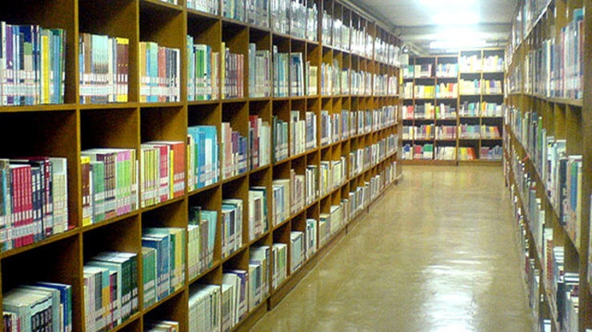

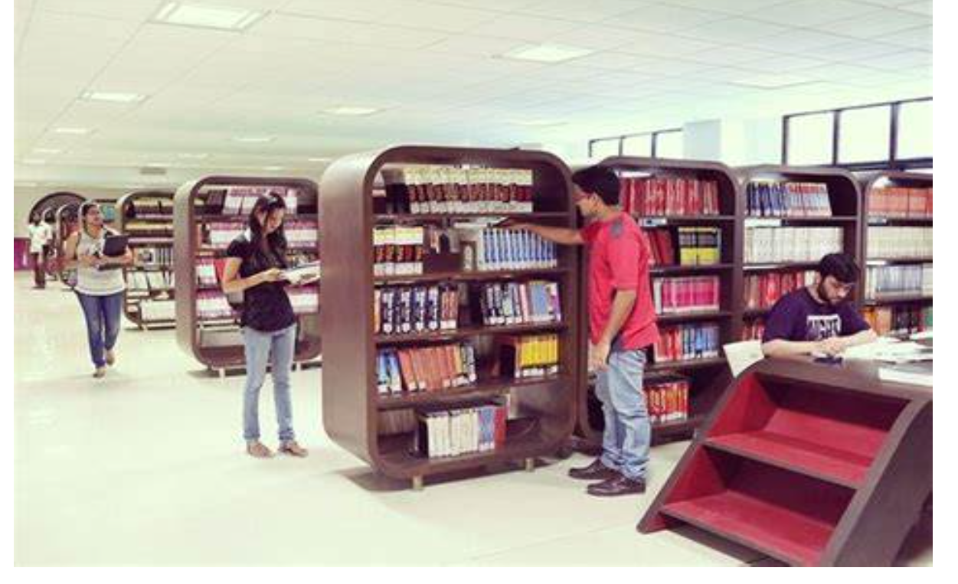

"Knowledge is power and library is the powerhouse". Books are the best teachers and counselors. To synchronize theory and practice, the journals, magazines and newspapers are very helpful. A Library is a collection of information, resources and services, organized for use, and maintained by a responsible body. Libraries inform the public of what materials are available in their collections and how to access that information. A modern Library provides educational resources to students and teachers through publications and other electronic media. The library is spanned in a 3000 sqft building with air-conditioning facility and it can accommodate 350 students for reading. The library is computerized and is well equipped with more than 7000 volumes of books various disciplines, 55 magazines and periodicals. The college has invested more than Rs 35 lakhs for the library in the last 4 years for the purchase of the books.The college

|  |
| --- |
|  |
|  |
|  |
|  |
|  |
|  |
|  |
|  |
|  |
|  |
|  |
|  |
|  |
|  |
|  |
|  |
|  |
|  |
|  |
|  |
|  |
|  |
|  |
|  |
|  |
|  |
|  |
|  |
|  |
|  |
|  |
|  |
|  |
|  |
|  |
|  |
|  |
|  |

spends a minimum of Rs 5 lakhs each year on the books and Rs 2 lakhs for subscribing the journals and periodicals.

**Hostel**

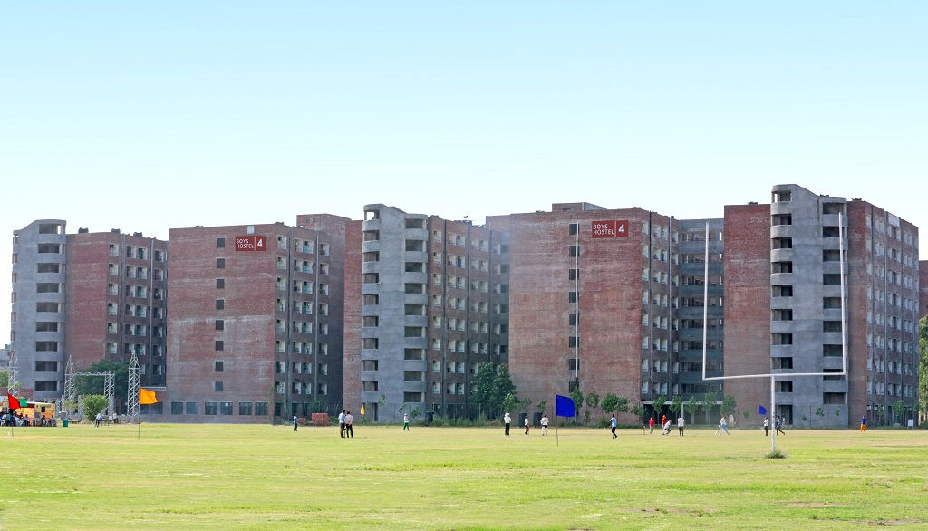

Hostels for students reflect corporate fitness in design and functionality, with separate infrastructure for men and women. The campus hostels are again an opportunity for cross integration of student learning with corporate life where the student is able to share knowledge and learn from his mentors the workplace competencies. We have separate hostels for men and women viz. KGiSL-Boys Hostel & KGiSL-Girls Hostel.

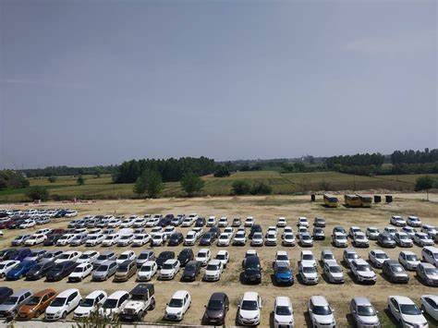

**Garden**

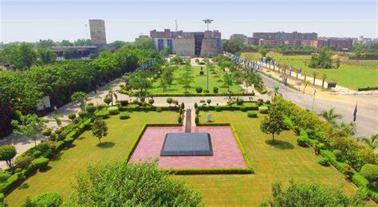

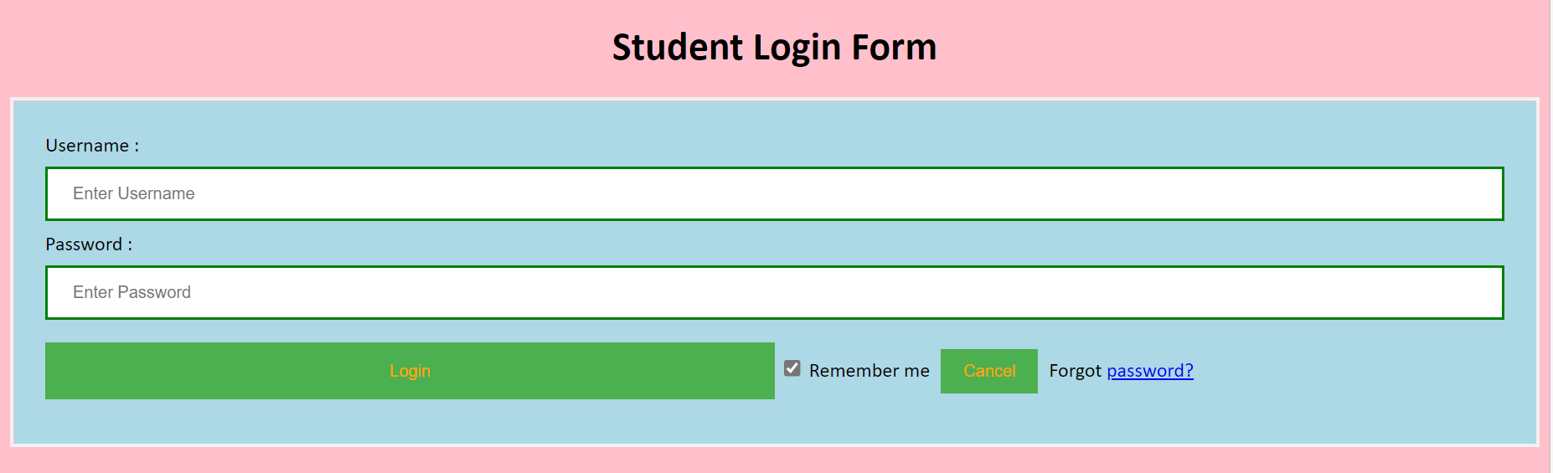

|  |  |
| --- | --- |
|  |  |
|  | **Code**  <!DOCTYPE html> |
|  | <html> |
|  | <head> |
|  | <meta name="viewport" content="width=device-width, initial-scale=1"> |
|  | <title> Login Page </title> |
|  | <style> |
|  | Body { |
|  | font-family: Calibri, Helvetica, sans-serif; |
|  | background-color: pink; |
|  | } |
|  | button { |
|  | background-color: #4CAF50; |
|  | width: 50%; |
|  | color: orange; |
|  | padding: 15px; |
|  | margin: 10px 0px; |
|  | border: none; |
|  | cursor: pointer; |
|  | } |
|  | form { |
|  | border: 3px solid #f1f1f1; |
|  | } |
|  | input[type=text], input[type=password] { |
|  | width: 100%; |
|  | margin: 8px 0; |
|  | padding: 12px 20px; |
|  | display: inline-block; |
|  | border: 2px solid green; |
|  | box-sizing: border-box; |
|  | } |
|  | button:hover { |
|  | opacity: 0.7; |
|  | } |
|  | .cancelbtn { |
|  | width: auto; |
|  | padding: 10px 18px; |
|  | margin: 10px 5px; |
|  | } |
|  |  |
|  |  |
|  | .container { |
|  | padding: 25px; |
|  | background-color: lightblue; |
|  | } |
|  | </style> |
|  | </head> |
|  | <body> |
|  | <center> <h1> Student Login Form </h1> </center> |
|  | <form> |
|  | <div class="container"> |
|  | <label>Username : </label> |
|  | <input type="text" placeholder="Enter Username" name="username" required> |
|  | <label>Password : </label> |
|  | <input type="password" placeholder="Enter Password" name="password" required> |
|  | <button type="submit">Login</button> |
|  | <input type="checkbox" checked="checked"> Remember me |
|  | <button type="button" class="cancelbtn"> Cancel</button> |
|  | Forgot <a href="#"> password? </a> |
|  | </div> |
|  | </form> |
|  | </body> |
|  | </html> |

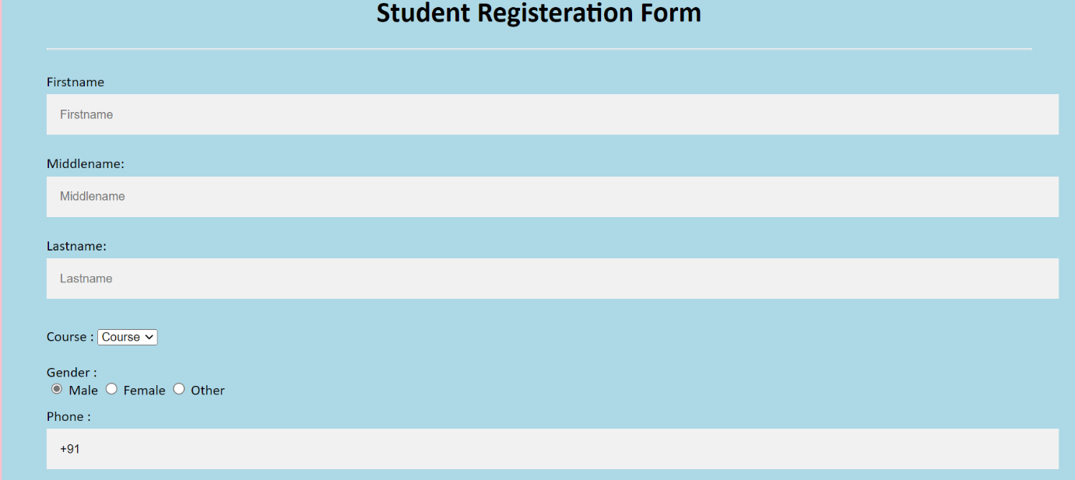

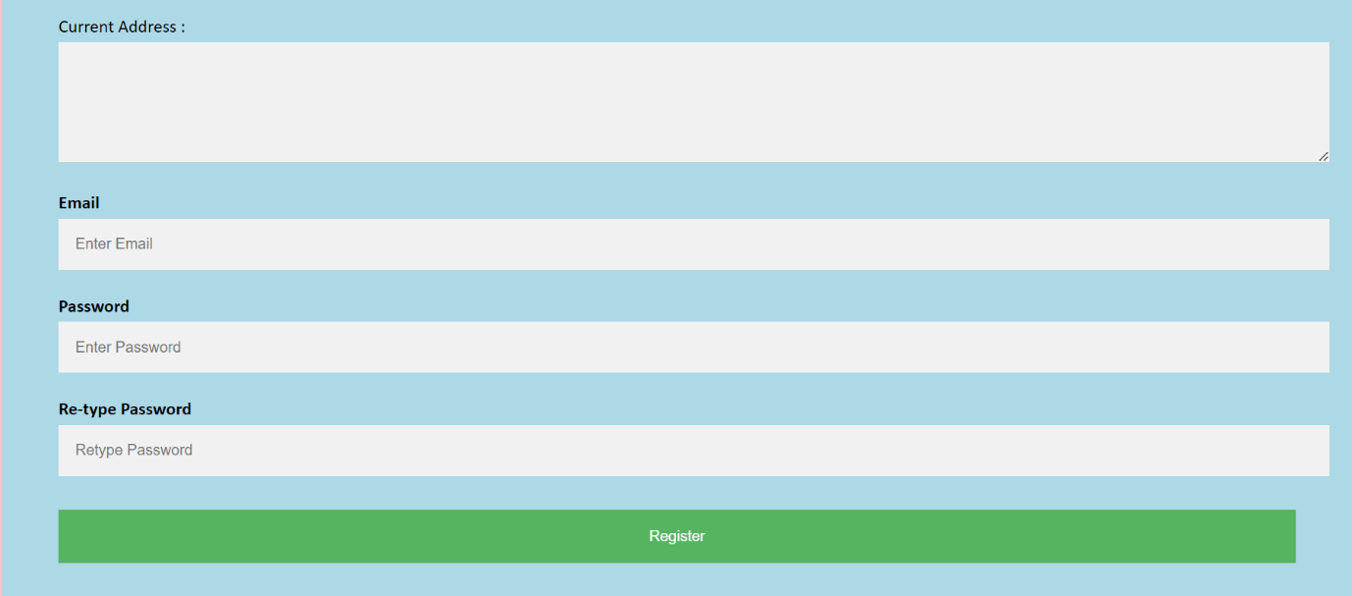

|  |  |
| --- | --- |
|  | **Code** |
|  | <!DOCTYPE html> |
|  | <html> |
|  | <head> |
|  | <meta name="viewport" content="width=device-width, initial-scale=1"> |
|  | <style> |
|  | body{ |
|  | font-family: Calibri, Helvetica, sans-serif; |
|  | background-color: pink; |
|  | } |
|  | .container { |
|  | padding: 50px; |
|  | background-color: lightblue; |
|  | } |
|  |  |
|  | input[type=text], input[type=password], textarea { |
|  | width: 100%; |
|  | padding: 15px; |
|  | margin: 5px 0 22px 0; |
|  | display: inline-block; |
|  | border: none; |
|  | background: #f1f1f1; |
|  | } |
|  | input[type=text]:focus, input[type=password]:focus { |
|  | background-color: orange; |
|  | outline: none; |
|  | } |
|  | div { |
|  | padding: 10px 0; |
|  | } |
|  | hr { |
|  | border: 1px solid #f1f1f1; |
|  | margin-bottom: 25px; |
|  | } |
|  | .registerbtn { |
|  | background-color: #4CAF50; |
|  | color: white; |
|  | padding: 16px 20px; |
|  | margin: 8px 0; |
|  | border: none; |
|  | cursor: pointer; |
|  | width: 100%; |
|  | opacity: 0.9; |
|  | } |
|  | .registerbtn:hover { |
|  | opacity: 1; |
|  | } |
|  | </style> |
|  | </head> |
|  | <body> |
|  | <form> |
|  | <div class="container"> |
|  | <center> <h1> Student Registeration Form</h1> </center> |
|  | <hr> |
|  | <label> Firstname </label> |
|  | <input type="text" name="firstname" placeholder= "Firstname" size="15" required /> |
|  | <label> Middlename: </label> |
|  | <input type="text" name="middlename" placeholder="Middlename" size="15" required /> |
|  | <label> Lastname: </label> |
|  | <input type="text" name="lastname" placeholder="Lastname" size="15"required /> |
|  | <div> |
|  | <label> |
|  | Course : |
|  | </label> |
|  | <select> |
|  | <option value="Course">Course</option> |
|  | <option value="BCA">BCA</option> |
|  | <option value="BBA">BBA</option> |
|  | <option value="B.Tech">B.Tech</option> |
|  | <option value="MBA">MBA</option> |
|  | <option value="MCA">MCA</option> |
|  | <option value="M.Tech">M.Tech</option> |
|  | </select> |
|  | </div> |
|  | <div> |
|  | <label> |
|  | Gender : |
|  | </label><br> |
|  | <input type="radio" value="Male" name="gender" checked > Male |
|  | <input type="radio" value="Female" name="gender"> Female |
|  | <input type="radio" value="Other" name="gender"> Other |
|  |  |
|  | </div> |
|  | <label> |
|  | Phone : |
|  | </label> |
|  | <input type="text" name="country code" placeholder="Country Code" value="+91" size="2"/> |
|  | <input type="text" name="phone" placeholder="phone no." size="10"/ required> |
|  | Current Address : |
|  | <textarea cols="80" rows="5" placeholder="Current Address" value="address" required> |
|  | </textarea> |
|  | <label for="email"><b>Email</b></label> |
|  | <input type="text" placeholder="Enter Email" name="email" required> |
|  |  |
|  | <label for="psw"><b>Password</b></label> |
|  | <input type="password" placeholder="Enter Password" name="psw" required> |
|  |  |
|  | <label for="psw-repeat"><b>Re-type Password</b></label> |
|  | <input type="password" placeholder="Retype Password" name="psw-repeat" required> |
|  | <button type="submit" class="registerbtn">Register</button> |
|  | </form> |
|  | </body> |
|  | </html> |

|  |  |
| --- | --- |
|  |  |
|  |  |
|  |  |
|  |  |
|  |  |
|  |  |
|  |  |
|  |  |
| |  |  |  | | --- | --- | --- | |  |  | **Code**  <html> | |  |  | <head> | |  |  | <title>time table</title> | |  |  | </head> | |  |  | <body bgcolor="yellow"> | |  |  | <H1><FONT COLOR="DARKCYAN"><CENTER>COLLEGE TIME TABLE</FONT></H1> | |  |  | <table border="2" cellspacing="3" align="center"> | |  |  | <tr> | |  |  | <td align="center"> | |  |  | <td>9:00-10:00 | |  |  | <td>10:00-11:00 | |  |  | <td>11:00-12:00 | |  |  | <td>12:00-1:00 | |  |  | <td>1:00-2:00 | |  |  | <td>2:00-3:00 | |  |  | <td>3:00-4:00 | |  |  | <td>4:00-5:00 | |  |  | </tr> | |  |  | <tr> | |  |  | <td align="center">MONDAY | |  |  |  | |  |  | <td align="center"><font color="blue">pratical/G:0 <br>C:INT108/<br>R:38-817/S:K22AE<br> | |  |  |  | |  |  | <td align="center"><font color="red">pratical/G:0 <br>C:INT108/<br>R:38-817/<BR>S:K22AE<br> | |  |  | <td align="center"><font color="red">Pratical/G:0<br>C:CSE326/<br>R:38-817/<BR>S:K22AE<BR> | |  |  |  | |  |  |  | |  |  | <td rowspan="5"align="center">L<br>U<br>N<br>C<br>H | |  |  | <td align="center"><font color="maroon">Lecture/G:All<br>C:CSE111/<BR>R:38-717/<BR>S:K22AE<br> | |  |  | <td align="center"><font color="brown">Lecture/G:All<br>C:CHE110/<BR>R:38-717/<BR>S:K22AE<br> | |  |  | <td colspan="2" align="center">---- | |  |  | </tr> | |  |  | <tr> | |  |  | <td align="center">TUESDAY | |  |  | <td align="center"><font color="blue">Pratical/G:2<BR> C:ECE279/<BR>R:36-101/<BR>S:K22AE<br> | |  |  | <td align="center"><font color="red">Pratical/G:2<BR> C:ECE279/<BR>R:36-101/<BR>S:K22AE<br> | |  |  | <td align="center"><font color="green">Lecture/G:2<BR> R:MTH174/<BR>R:33-505/<BR>S:K22AE<br> | |  |  | <td align="center"><font color="RED">Lecture/G:All<BR> C:INT108/<BR>R:38-715/S:K22AE<BR> | |  |  | <td align="center"><font color="RED">Lecture/G:All<BR> C:INT108/<BR>R:38-715/S:K22AE<BR> | |  |  |  | |  |  | <td colspan="2" align="center">------ | |  |  | </tr> | |  |  | <tr> | |  |  | <td align="center">WEDNESDAY | |  |  | <td align="center"><font color="RED">Pratical/G:0<br>C:CSE326/<br>R:38-913/<BR>S:K22AE<br> | |  |  | <td align="center"><font color="BLUE">Pratical/G:0<br>C:CSE326/<br>R:38-817/<BR>S:K22AE<BR> | |  |  | <td align="center"><font color="brown">Lecture/G:All<BR> C:INT108/<BR>R:38-913/S:K22AE<br> | |  |  | <td align="center"><font color="brown">Lecture/G:2<BR> R:MTH174/<BR>R:33-505/<BR>S:K22AE<br> | |  |  | <td align="center"><font color="brown">Lecture/G:All<br>C:CHE110/<BR>R:38-717/<BR>S:K22AE<br> | |  |  | <td align="center"><font color="brown">Lecture/G:2<BR> C:ECE279/<BR>R:36-101/<BR>S:K22AE<br> | |  |  | <td colspan="1" align="center">--- | |  |  | </tr> | |  |  | <tr> | |  |  | <td align="center">THURSDAY | |  |  | <td align="center">Tutorial/G:2<BR> C:PES279/<BR>R:27-304Y/<BR>S:K22AE<br> | |  |  | <td align="center"><font color="brown">Tutorial/G:2<BR> C:PES279/<BR>R:27-304Y/<BR>S:K22AE<br> | |  |  | <td align="center"><font color="green">Lecture/G:2<BR> R:MTH174/<BR>R:38-716/<BR>S:K22AE<br> | |  |  | <td align="center"><font color="brown">Lecture/G:2<BR> C:ECE279/<BR>R:38-716/<BR>S:K22AE<br> | |  |  | <td colspan="3" align="center">--- | |  |  | </tr> | |  |  | <tr> | |  |  | <td align="center">FRIDAY | |  |  | <td align="center"><font color="orange">===<BR> | |  |  | <td align="center"><font color="maroon">===<br> | |  |  | <td align="center"><font color="blue">===<br> | |  |  | <td align="center"><font color="green">Tutorial/G:2<BR> R:MTH174/<BR>R:38-715/<BR>S:K22AE<br> | |  |  | <td align="center"><font color="brown">Pratical/G:0<br>C:CSE326/<br>R:38-817/<BR>S:K22AE<br> | |  |  | <td align="center"><font color="brown">Pratical/G:0<br>C:CSE326/<br>R:38-817/<BR>S:K22AE<br> | |  |  | <td align="center"><font color="brown">Pratical/G:0<br>C:CSE326/<br>R:38-817/<BR>S:K22AE<br> | |  |  |  | |  |  |  | |  |  | </tr> | |  |  | <tr> | |  |  | <td align="center">SATURDAY | |  |  | <td align="center"><font color="red">===<br> | |  |  | <td colspan="2" align="center">=== | |  |  | <td align="center"><font color="pink">===<br> | |  |  | <td align="center"><font color="brown">===<br> | |  |  | <td colspan="3"align="center">==== | |  |  | </tr> | |  |  | </body> | |  |  | </html>  **Submitted by:** **Submitted to:**  `1.**Name :**Satya Kumar Chaudhary **Name:**Dr.Suman Kamalesh Gandhimathi  **Section:**K22AE  **RollNo**:A31  **Reg:**12203506  2**.Name:**Ankit Kumar  **Section:**K22AE  **RollNo:**A34  **Reg:**12203722 |     Thank you |  |
|  |  |
|  |  |
|  |  |
|  |  |
|  |  |
|  |  |
|  |  |
|  |  |
|  |  |
|  |  |
|  |  |
|  |  |
|  |  |
|  |  |
|  |  |
|  |  |
|  |  |
|  |  |
|  |  |
|  |  |
|  |  |
|  |  |
|  |  |
|  |  |
|  |  |
| , |  |
|  |  |
|  |  |
|  |  |
|  |  |
|  |  |
|  |  |
|  |  |
|  |  |
|  |  |
|  |  |
|  |  |
|  |  |
|  |  |
|  |  |
|  |  |
|  |  |
|  |  |
|  |  |
|  |  |
|  |  |
|  |  |
|  |  |
|  |  |
|  |  |
|  |  |
|  |  |
|  |  |
|  |  |
|  |  |
|  |  |
|  |  |
|  |  |
|  |  |
|  |  |
|  |  |
|  |  |
|  |  |
|  |  |
|  |  |
|  |  |
|  |  |
|  |  |
|  |  |
|  |  |
|  |  |
|  |  |
|  |  |
|  |  |
|  |  |
|  |  |
|  |  |
|  |  |
|  |  |
|  |  |
|  |  |
|  |  |
|  |  |
|  |  |
|  |  |
|  |  |
|  |  |
|  |  |
|  |  |
|  |  |
|  |  |
|  |  |
|  |  |
|  |  |

|  |  |
| --- | --- |
|  |  |